
Class Supply List
Fancy Stitch Valentine Coasters
Diane Beckman
Moore’s of Brea
Saturday, January 13th
9:30 a.m. – 4 p.m.
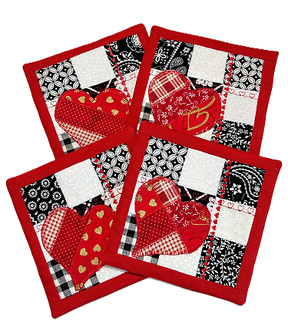

Supply List:

*Sewing machine with built in decorative stitches, ¼” quilting foot, open toe foot,
accessories, sewing attachments
*Fabric – Cotton, small prints. Choose your own colors (I used 5 different black, 8 different red, 4 white on white small prints, fabric for border and backing of coaster.)
Quilt batting
*Sewing thread – Colors to accent, coordinate with fabric
*Scissors, rotary cutter with blade, ruler, cutting mat
Mini iron optional
See cutting instructions following

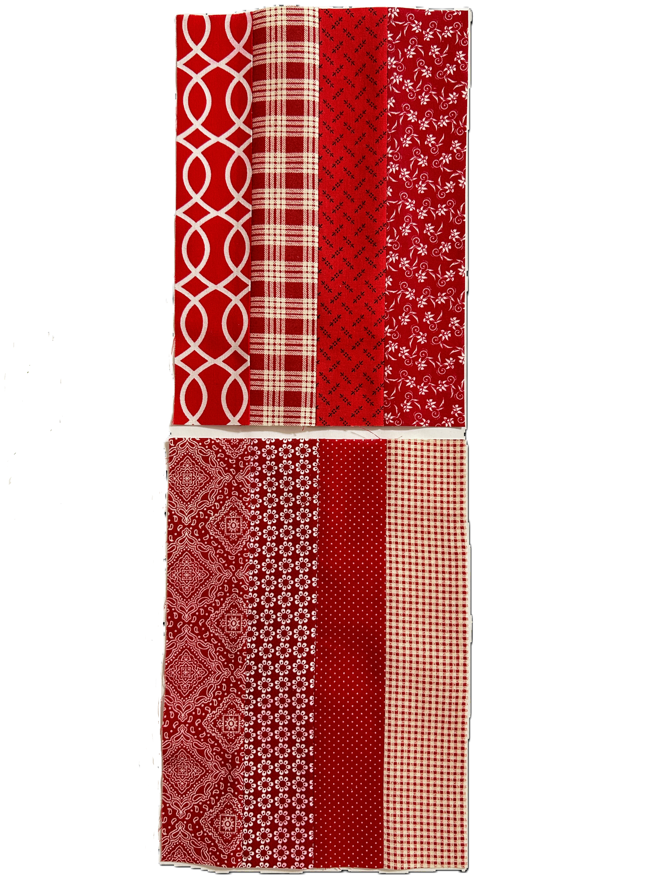
Precut Fabric – Cut fabric strips precisely. Quality cotton is best.

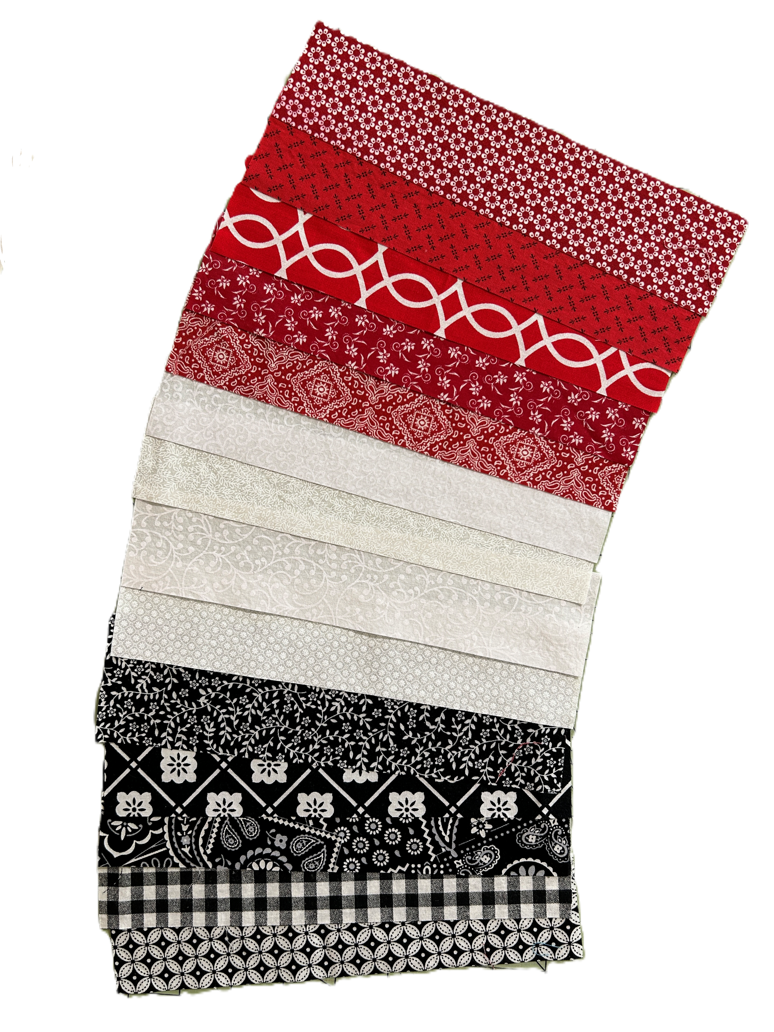
Pre wash fabric and press well first if you want.
Cut 5 strips of black (or color of choice) small prints 10” x 2”.
Cut 4 strips of white on white printed fabric 10” x 2”.
Cut 8 strips of red (or color of choice) small prints 10” x 2”.
Cut 16 strips of red (or color of choice) fabric for outside border 6-1/2” x 1-1/4”
Cut 8 pieces of fabric for back of coaster. 6”x8”
Cut 4 pieces of quilt batting 5” x 5”.

Bring extra fabric in case you need it.

All supplies with an * are available for purchase at Moore’s!

www.moores-sew.com

